PIZZA SALES SQL QUERIES

**KPI’S**

1. TOTAL REVENUE

Select SUM(total_price) AS Total_revenue from pizza_sales;

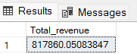

1. AVERAGE ORDER VALUE

SELECT SUM(total_price) / COUNT(DISTINCT order_id) AS Average_order_value FROM pizza_sales;



1. TOTAL PIZZAS SOLD

SELECT SUM(quantity) AS Total_Pizza_Sold from pizza_sales;



1. TOTAL ORDERS

SELECT COUNT(DISTINCT order_id) AS Total_Orders FROM pizza_sales;



1. AVERAGE PRICES PER ORDER

SELECT CAST(CAST(SUM(quantity) AS DECIMAL(10,2)) /

CAST(COUNT(DISTINCT order_id) AS DECIMAL(10,2)) AS DECIMAL(10,2)) AS Avg_Pizzas_per_order FROM pizza_sales



**B. Daily Trend for Total Orders**

SELECT DATENAME(DW, order_date) AS order_day, COUNT(DISTINCT order_id) AS total_orders

FROM pizza_sales

GROUP BY DATENAME(DW, order_date);

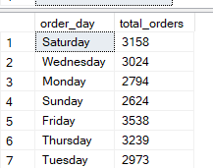

**HOURLY TRENDS FOR ORDERS**

SELECT DATEPART(HOUR ,order_time) as order_hours, COUNT(DISTINCT order_id) AS total_orders

FROM pizza_sales

GROUP BY DATEPART(HOUR ,order_time)

ORDER BY DATEPART(HOUR ,order_time);

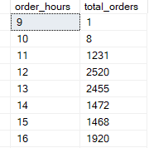

**% of Sales by Pizza Category**

SELECT pizza_category, SUM(total_price) *100 / (SELECT SUM(total_price) FROM pizza_sales ) FROM pizza_sales as TOTAL_SALES

GROUP BY pizza_category;

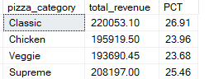

**% of Sales by Pizza Size**

SELECT pizza_size, CAST(SUM(total_price) AS DECIMAL(10,2)) as total_revenue,

CAST(SUM(total_price) * 100 / (SELECT SUM(total_price) from pizza_sales) AS DECIMAL(10,2)) AS PCT

FROM pizza_sales

GROUP BY pizza_size

ORDER BY pizza_size

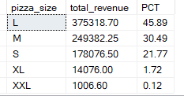

**Total Pizzas Sold by Pizza Category**

SELECT pizza_category, SUM(quantity) as Total_Quantity_Sold

FROM pizza_sales

WHERE MONTH(order_date) = 2

GROUP BY pizza_category

ORDER BY Total_Quantity_Sold DESC

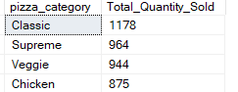

**Top 5 Best Sellers by Total Pizzas Sold**

SELECT Top 5 pizza_name, SUM(quantity) AS Total_Pizza_Sold

FROM pizza_sales

GROUP BY pizza_name

ORDER BY Total_Pizza_Sold DESC

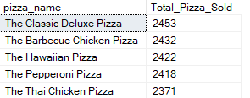

**Bottom 5 Best Sellers by Total Pizzas Sold**

SELECT TOP 5 pizza_name, SUM(quantity) AS Total_Pizza_Sold

FROM pizza_sales

GROUP BY pizza_name

ORDER BY Total_Pizza_Sold ASC

